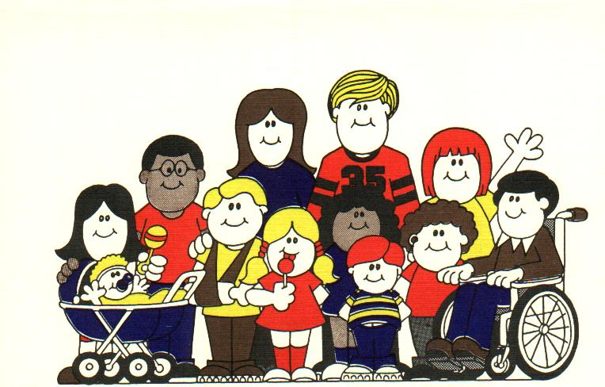

CANCELLATION POLICY

Cancellation: If you need to cancel a pre-scheduled appointment, please notify our office 24 hours in advance so we may accommodate other families who are waiting to schedule appointments for their children. Failure to cancel your appointment within 24 hours of your scheduled appointment will result in a no-show charge.

**No Show: There will be a no-show fee for every no-show appointment**.

Appointment for sick not cancelled 24 hours in advance = $ 30

Appointment for physical not cancelled 24 hours in advance= $ 50

Appointment for behavioral (ADD/ADHD), Anxiety, etc. = $ 75

Appointment with the psychiatric nurse practitioner 60 mins $100

Appointment with the psychiatric nurse practitioner 30 mins $ 60